User Manual

Syringe Driver for Veterinary Use

Vet Direct Syringe Driver

Preface

1 Application Scope
Applicable to Vet Direct Syringe Driver of our company.
This User Manual describes the product’s most complete configuration, the accessories and functions may not be existed in the product of the user, for more detailed information, please contact supplier.

2 Applicable Object
It is applicable to trained, veterinary professionals, and maintenance technicians of this equipment.

3 Use Instructions
This User Manual covers the basic information on the safety and effectiveness of the product for guiding the operator to correctly install, test, operate, use and maintain the product. Please read this manual thoroughly before use.
Our company is responsible for the reliability and performance of the equipment only if all the following conditions are met:
- Use the equipment according to this User Manual.
- The equipment can only be disassembled, assembled, replaced, tested, improved and repaired by the professional technicians of our company.
- All components and accessories as well as consumables for repairing are provided by manufacturer.
- Relevant electric devices meet the international standard IEC/EN 60601-1 and this User Manual.

4 Paraphrase
【】 means mechanical button
『』 means touch button
( ) further Information
- means inapplicable
√ means accordant
→ means operation steps
Bolus: Infuse large volume liquid in a short time.
KVO: Keep the vein open, prevent blood back to the syringe extension line and needle to be blocked.
Anti-bolus: Motor automatically reverse while the syringe extension line needle with high pressure.
IrDA: Infrared communication
Warning /Attention: it may possibly cause physical injury or death if the cautions covered in the Warning are not obeyed.
Caution: it may possibly cause physical injury or property loss if the cautions are not obeyed.
Note: in case fails to follow the supplementary or prompt information on the operation instructions may possibly cause physical injury the equipment fault or property loss if it is not obeyed.
Accessories: the optional components which are necessary and (or) suitable for using with the equipment in order to achieve the expected purpose, or provide convenience for achieving the expected purpose, or improve the expected purpose, or increase the additional functions of the equipment.

5 Description on Revision of User Manual
The copyright of this User Manual belongs to Shenzhen MedRena Biotech Co., Ltd. Without declaration any institute or individual are prohibited to copy, modify or translate the contents speculated in this User Manual.
This User Manual will be revised subject to product improvement, laws updating or instructions improving basing on the preconditions of meeting related laws and regulations, and all revised records will be stated in the new version.

Version | Revising Date | Revised Content
V1.0 | 2018.9.20 | First edition
V2.0 | 2022.1.5 | - Change production address ;  - Add material code at the end of the manual
V2.1-VD | 2024.1.8 | Vet Direct Syringe Driver Version

Content
Preface 1
1 Application Scope 1
2 Applicable Object 1
3 Use Instructions 1
4 Paraphrase 1
5 Description on Revision of User Manual 2
Chapter1 Safety Instructions 7
1.1 Warnings 7
1.2 Cautions 9
1.3 Dialogue window 10
1.4 Symbols 10
Chapter2 Overview 11
2.1 Application Scope 11
2.1.1 Expected Purpose 11
2.1.2 Expected Working Environment 11
2.1.3 Suitable object 11
2.2 Contraindications 11
2.3 Working Principle 11
2.4 Structure and Performance 11
2.4.1 Structure and Performance 11
2.4.2 Accessories 11
2.5 Product Specification 12
Chapter3 Appearance 15
3.1 FRONT VIEW 15
3.2 OPERATION PANEL 16
3.3 Display Screen 17
3.3.1 Title Bar 17
3.3.2 Typical Interface 17
3.3.2.1 Typical Interface Icon Paraphrase 18
3.3.2.2 Input Method Interface 18
3.4 Rear View 19
Chapter4 Installation 20
4.1 Unpacking and Checking 20
4.2 Installation 20
4.2.1 Install the Syringe Driver 21
Chapter5 Use Preparation and Cautions 22
5.1 Use Preparation 22
5.2 Operation Cautions 22
Chapter6 Basic Operation 23
6.1 Operation Flow 23
6.2 Infusion Operation 24
6.2.1 Equipment Installation 24
6.2.2 Starting and Self-test 24
6.2.3 Install Syringe 24
6.2.4 Set Infusion Parameters 25
6.2.5 Remove Air bubble 25
6.2.6 Start Infusion 25
6.2.7 Change the Rate During Infusion 25
6.2.8 Bolus Application 26
6.2.9 Infusion Completion 26
6.2.10 Stop Infusion 26
6.2.11 Remove the syringe 26
6.2.12 Power OFF or Standby 27
Chapter7 Set Infusion Parameters 28
7.1 Introduction to Infusion Parameters Setting 28
7.2 Infusion Parameters Setting Range 28
7.3 Infusion Mode Setting 28
7.3.1 Rate Mode 29
7.3.2 Time Mode 29
7.3.3 Body Weight Mode 29
Chapter8 System Setting 30
8.1 Settings 30
8.1.1 Drug Library 30
8.1.2 KVO Rate 30
8.1.3 Bolus Rate 30
8.1.4 Commonly used syringe brand 30
8.1.5 DPS 30
8.1.6 Occlusion Pressure 30
8.1.7 Pressure Unit 31
8.1.8 Reminder Alarm 31
8.1.9 Finish Pre-alarm 32
8.1.10 Micro Mode 32
8.1.11 Reset Total Volume 32
8.2 General 32
8.2.1 Date & Time 32
8.2.2 Brightness 33
8.2.3 Sound 33
8.2.4 Screen Lock 33
8.2.5 Night Mode 33
8.2.6 Battery capacity display 33
8.2.7 Nurse Call 33
8.2.8 Nurse call alarm level 34
8.2.9 Net Work 34
8.3 System 34
8.3.1 Language 34
8.3.2 Factory Default 34
8.3.3 Version 35
8.3.3.1 SN (Serial Number) 35
8.3.3.2 Software version 35
8.3.4 Maintenance 35
Chapter9 Other Functions 36
9.1 Patient Information System 36
9.1.1 Patient Information 36
9.1.2 Prescription 36
9.2 History entries 36
Chapter10 Alarm Prompt and Troubleshooting 37
10.1 Introduction to Alarm Level 37
10.2 Multilevel Alarm Rules 37
10.3 Alarm Treatment 38
10.4 Fault Analysis and Solution 38
Chapter11 Maintenance 39
11.1 Cleaning, disinfecting and sterilizing 39
11.1.1 Cleaning 39
11.1.2 Disinfecting 39
11.2 Periodical maintenance 40
11.2.1 Check the Appearance 40
11.2.2 Performance Check 40
11.2.3 Maintenance Plan 40
11.3 Calibration 41
11.4 Repair 42
11.4.1 Normal Repair Process 42
11.4.2 Maintenance for Long Term Store 42
11.5 Equipment Components/Accessories 42
11.6 Production Date 43
11.7 Recycling 43
Chapter12 Battery 44
12.1 Check the Battery Performance 44
12.2 Replaced the Battery 44
Chapter13 After Sale Service 45
Chapter14 Appendix 46
Appendix A Start Up Graphs and Trumpet Curves 46
Appendix B Occlusion Response Property 48
Appendix C Alarm and Solution 49
Appendix D Electro Magnetic Compatibility declaration 51
Appendix E Factory Default Data Set 56

Safety Instructions

Warnings

- Before using, please check the equipment, connecting wire and accessories to ensure that it can work normally and safely. If there’s anything abnormal, immediately stop working and contact our after sale service department. Additionally, the adhesion or intrusion of fluid/drug may possibly cause the equipment fault and malfunction. Therefore, please clean the equipment after use, and store it correctly.

- This equipment must be operated by trained professional medical care personnel.

- This equipment is not applicable to blood transfusion.

- It is not allowed to put and use the equipment in the environment with anesthetic and other inflammable or explosive articles to avoid fire or explosion.

- It is not allowed to store or use the equipment in the environment with active chemical gas (including gas for disinfecting) and moist environment since it may influence the inside components of the syringe driver and may possibly cause performance drop or damage of the inside components.

- The operator shall guarantee that the inputted infusion parameters of this equipment are the same as the medical advice before starting infusion.

- Please do not only depend on alarm system during use, please periodically check it to avoid accident.

- Tightly fix this equipment on the infusion stand and ensure the stability of the infusion stand. Be careful when moving the infusion stand and this equipment to avoid the equipment dropping and infusion stand falling or knocking the surrounding objects.

- If the syringe extension line is twisted, or the filter or needle is obstructed, or blood in the needle which may obstruct the syringe, the pressure in the syringe will rise. When removing such occlusion, it may possibly cause “bolus infusion” (temporary excess infusion) to the patient. The correct method is to tightly hold or clamp the extension line near the puncturing position, then loosen the syringe, solve the reason of occlusion, and restart infusion. If infusion is restarted when the occlusion reason exists, then it may cause occlusion alarm persistently, and the pressure in the syringe may keep rising, and may break or cut off the connection, or hurt the patient.

- This equipment has the occlusion detection function for detecting and alarming when the syringe needle deviates the position in the vein or the needle is not correctly punctured in the vein. However, it only alarms when the occlusion pressure has reached certain numerical value, and the puncturing part may possibly have become reddish, swelling or bleeding, additionally, it is possible that the device doesn’t alarm for a long period if the actual occlusion pressure is lower than the alarm threshold value, therefore, please periodically check the puncturing part. If there’s any abnormal phenomenon for the puncturing part, please timely take suitable measures, such as puncturing again.

- Only those sterile hypodermic syringes for single use and other medical components that meet the local laws and regulations and the requirements covered in and this User Manual can be adopted, it is suggested to adopt the syringe with same brand as defaulted in this equipment. It can’t ensure the infusion accuracy if the unsuitable syringe line is adopted. Please use the syringe and the extension line with luer taper, or may be because of the extension line pop off to cause damage to the patient.

- It is not allowed to disassemble or refit this equipment or use it for other purposes except normal infusion.

- No one is allowed to repair this equipment except our company or the authorized repair technician of our company.

- To avoid risk of electric shock, this equipment must only be connected to a supply main with
protective earth

Cautions
- Before its first use after purchase, or this equipment is not used for a long period, please charge the equipment with AC power supply. If it is not fully charged, under power failure, the equipment can’t continue working with built-in battery power supply.

- This equipment can’t be used in the places with radiological installation or magnetic resonance equipment as well as the places with high pressure oxygen therapy.

- Other devices near this equipment must meet corresponding EMC requirements, otherwise, it may influence the performance of this equipment.

- Under general conditions, please use AC power supply as much as possible since it can prolong the service life of the battery at a certain degree. When using AC power supply, ensure that the grounding wire is reliably connected with the ground, and only the AC power cord attached with this equipment shall be adopted, please pay attention to the plug position of the power cord to ensure that you can disconnected it at any time. The built-in battery can only be used as the assistant power supply when the AC power supply can’t reliably connect with the ground and is not under normal conditions (power failure or in-transport infusion).

- Before connecting this equipment with power supply, please keep the power socket and plug dry, and the power voltage and frequency meet the requirements listed in the equipment label or this User Manual.

- The equipment is equipped with the audible and visual alarm system, the red and yellow alarm indicators will light on by turn to check if the alarm system can work normally, and the speaker makes the “beep” sound.

- Please keep the equipment away from the AC power socket for a certain distance to avoid fluid/drug splashing or dropping in the socket, otherwise, it may possibly cause short circuit.

- Please use the fluid/drug after it has reached or nearly reached room temperature. When the fluid/drug is used at low temperature, the air which is dissolved in the fluid/drug may cause more air bubbles.

- It is not allowed to press and operate the button with sharp object (such as pencil tip and nail), otherwise, it may possibly cause early damage to button or surface film.

- Under the condition of low flow rate infusion, please pay special attention on occlusion. The lower the infusion flow rate, the longer the time of detecting occlusion, and it in turn may possibly cause a long- time infusion stop during this period.

- If the equipment suffered from dropping or impacting, please stop using it immediately, and contact our after-sale service department, because the inside components of the equipment may be possibly damaged even the appearance is not damaged and abnormality is not occurred when working.

Dialogue window
Dialogue window mainly content include operation select, operation confirm etc. tips information. For instance:

Symbols
Not all of the below symbols are existed in the equipment you have purchased.
Table:1.4-1

Marks | Description | Marks | Description
 | Lot Number |  | Class I Equipment
 | Serial Number | IP34 | Ingress Protection (Prevent solid objects larger than 2.5mm in diameter and water intrusion from splashing in all directions)
 | Attention, consult  accompanying documents |  | Alternating Current
 | Defibrillation proof type CF applied Part |  | Handle with harmless method
 | Date of Manufacture |  | Manufacturer
 | environment-friendly use  period (20 years) |  | Non-ionizing radiation
 | Authorized Representative in the European Community |  | Please refer to User Manual /Handbook
 | Unlock |  | Lock
 | Input and output

Overview

Application Scope

Expected Purpose
This product is used for constant speed intravenous infusion in hospital.

Expected Working Environment
Including but not limiting to: The operation room, surgery table in Animal hospital/or Pet clinic.

Suitable object
Companion animals

Contraindications
No

Working Principle
It is controlled to move into a linear motion from a microcontroller based system which drives a step motor, allowing a wide range of pumping rates configured to the inside diameter of the loaded syringe. The syringe plunger is driven from a lead screw and drive-nut mechanism, infusing the drugs into the patient.

Structure and Performance

Structure and Performance
The syringe driver mainly composes of the main unit and built-in battery. This equipment provides several infusion modes, such as rate mode, time mode, body weight mode, drug library mode, ramp up/down mode, loading dose mode, sequence mode, and TIVA mode. Additionally, it also has functions such as history records, drug library, Anti-bolus, and alarm and so on.

Accessories
Optional accessories include a protective cover, the protective cover is used to protect the Slider box.

Product Specification
Safety Classification
Electric protection Type | Class I
Electric protection Level | Defibrillation proof type CF applied Part
Ingress Protection | IP34 (Prevent solid objects larger than 2.5mm in diameter and water intrusion from splashing in all directions)
Working mode | Continuous
Classification | Portable equipment, non-portable syringe driver
Specification Parameters
Compatible Syringes | 5ml, 10ml, 20ml, 30ml, 50/60ml
System Accuracy | ≥1ml/h, ±2%  ＜1ml/h, ±5%
Infusion Rate | Syringe size 5ml: (0.1-150) ml/h  Syringe size 10ml: (0.1-300) ml/h  Syringe size 20ml: (0.1-600) ml/h  Syringe size 30ml: (0.1-900) ml/h  Syringe size 50ml: (0.1-1500) ml/h
Bolus Rate | Syringe size 5ml: (0.1-150) ml/h  Syringe size 10ml: (0.1-300) ml/h  Syringe size 20ml: (0.1-600) ml/h  Syringe size 30ml: (0.1-900) ml/h  Syringe size 50ml: (0.1-1500) ml/h
Bolus preset value | Min: 0.1ml Max: max rate of accordingly loaded syringe size
KVO Rate | 0-5.00ml/h
Micro mode  setting range | Syringe size 5ml: (100-150) ml/h  Syringe size 10ml:(100- 300) ml/h  Syringe size 20ml: (100-600) ml/h  Syringe size 30ml: (100-900) ml/h  Syringe size 50ml: (100-1500) ml/h
Minimum flow rate increment | 0.01ml/h
VTBI | 0-9999.99ml, minimum step is 0.01ml
Total Volume Infused | 0-9999.99ml, minimum step is 0.01ml
Time Range | 1min-99hrs59min
Fuse Type | slow fuse 2A 250V
Dimensions | 242.5(W)*111(D)*126.5(H) mm
Weight | 1.7kg
Power Supply
AC power supply | 100-240V 50/60Hz
Input power | 50VA
DC power supply | DC 12V
Battery Specifications | Specification: 7.4V 2500mAh  Charging time: single battery less than 2.5hrs, two batteries less than 5hrs (under OFF status).  Working time: single battery over 5.5hrs, two batteries over 11hrs. (after completely charging battery/batteries, when the environment temperature is 25℃ and flow rate is 5ml/h, the constantly working time)
Alarm
Alarm signal sound pressure level | When the sound is set at lowest level, alarm signal sound pressure level ≥50dB(A)  When the sound is set at highest level, alarm signal sound pressure level ≤80dB(A)
Alarm information | VTBI near end, Syringe near empty, VTBI infused, Syringe empty, Pressure high, Battery nearly empty, Battery empty, No battery inserted,  No power supply, Check syringe, Pump idle alarm, Standby time expired,  KVO finished
Environment
Non AP/APG type equipment | Do not use it in the environment with inflammable anaesthetic gas mixed with air, and inflammable anaesthetic gas mixed with oxygen or nitrous oxide
Operating | (1) temperature: 5-40℃  (2) humidity: 15-95%, non-condensable  (3) atmospheric pressure: 57-106kPa
Transport & Storage | (1) temperature: -20-55℃  (2) humidity: 10-95%, non-condensable  (3) atmospheric pressure: 50-106kPa

Safety Standard
Main Safety Standards | IEC 60601-1:2005+A1:2012  Medical Electrical Equipment, Part 1: General Requirements for basic safety and essential performance  IEC60601-2-24:2012 Medical electrical equipment – Part 2-24: Particular requirements for the safety  of syringe drivers and controllers  IEC60601-1-8：2006  +A1：2012  Medical electrical equipment –Part 1-8: General requirements for basic safety  and essential performance –Collateral Standard: General requirements, tests and guidance for alarm systems in medical electrical equipment and medical  electrical systems  EN60601-1-2:2007+AC:2010  Medical Electrical Equipment - Part1-2: General requirements for basic safety  and essential performance-Collateral standard: Electromagnetic compatibility-Requirements and tests

Appearance

FRONT VIEW
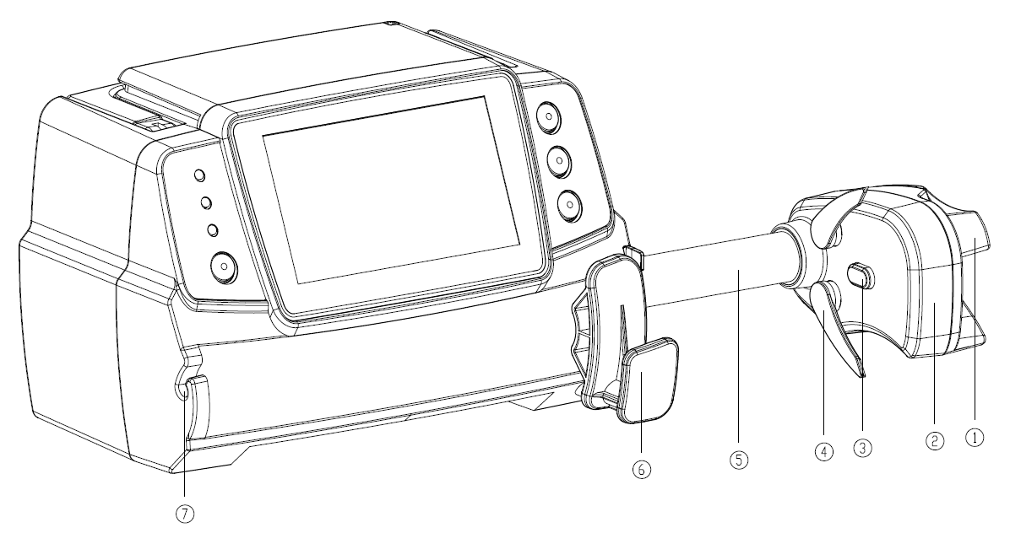
① Handle
Control syringe driver push-pull sliding box and clip.
② Slider box
③ Pressure sensor
Detect the pressure of the syringe
④ Syringe clip
Clamp the syringe plunger
⑤ Lead-screw
⑥ Syringe fixture lever
Pull forward then turn 90° right or left , install the syringe into the slot.
⑦ Extension line Clamp
Keep the extension line in line and neat

OPERATION PANEL
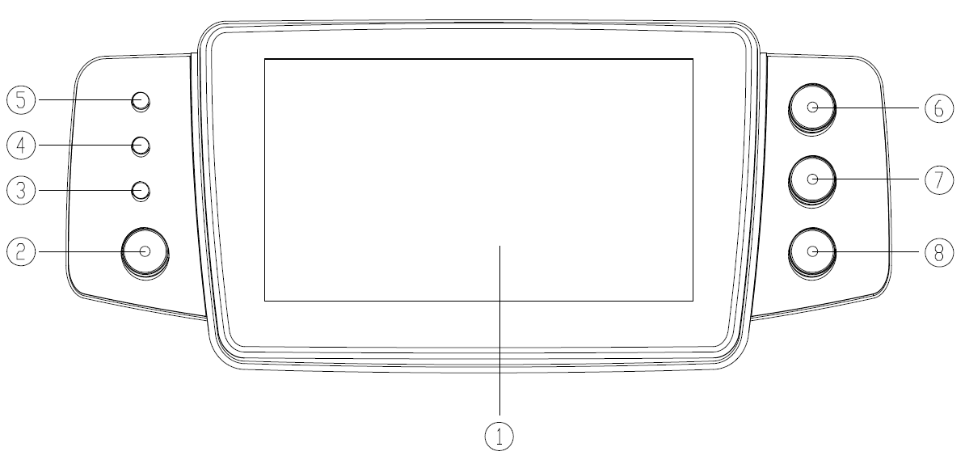
① Touch Screen
②【Power】
Pump power switch, press and hold for 3 seconds, pump power off. Standby selection button.
③ AC indicator light
When connecting with AC power supply, AC indicator lights on.
④ Alarm indicator light
While pump alarms, indicator light glitter, different level different frequency and color, more information please refer to Chapter 10.1.
⑤ Running lights
⑥【Start/stop】
⑦【Bolus/Purge】
⑧【Home】
Enter system home page.

Display Screen
The display screen interface layout composes of title bar and typical interface.

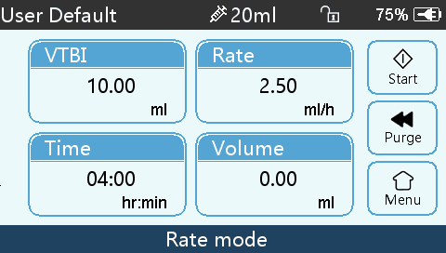

Title Bar
Title bar displays real-time state information and is not touchable, the left upper corner displays the name of current editing parameter.

Table3.4.1-1: Title Bar Icon

Icon | Paraphrase | Description
 | Syringe apparatus indication icon | Syringe apparatus indication icon
 | Lock screen indication icon | Unlock state icon is
 | WIFI indication icon | Indicate WIFI connection state.
 | Battery charging indication icon | Display the current battery charging state
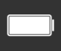 | Battery status indication icon | The percentage numerical value at the left side of the icon displays the remained battery.  Since the remained battery may change, it may possibly show the following states:  

Typical Interface
During pre-infusion and infusion, the typical interface will display the following: main interface, working interface, alarm interface, prompt interface, control panel, parameters setting, input method, standby interface etc.

Typical Interface Icon Paraphrase
Table:3.4.2.1-1

Icon | Paraphrase | Description
 | Start | Click this icon, start infusion
 | Stop | Click this icon, infusion stop
 | Bolus/Purge | 1. During infusion, it is『Bolus』function, click it to start fast infusion  2. Before infusion starting, it is『Purge』function, click it to exhaust air from the syringe
 | Home | Click this icon, return to the main interface

Input Method Interface
The input method interface composes of the title bar, input box, editing box.

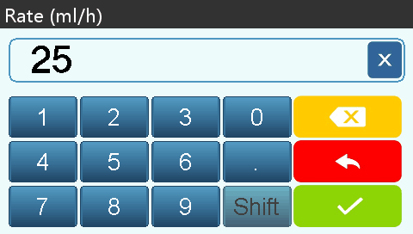

- Title bar: display the name of current editing parameter.
- Input box: real-time display the input content.
- Editing box: It composes of the main button area and function button area.
The main button area composes of the numerical value, letters and icons, click it continuously to change the sequence.

The function button area composes of clear button, backspace button, 『』, 『』,『』and『Shift』.

Icon | Paraphrase | Description
 | Backspace button | Click it to backspace delete
Shift | Shift button | Click it to switch the capital and lowercase English letters
 | Cancel button | Click it to cancel editing and exit
 | OK button | Click it to save editing and exit

Rear View
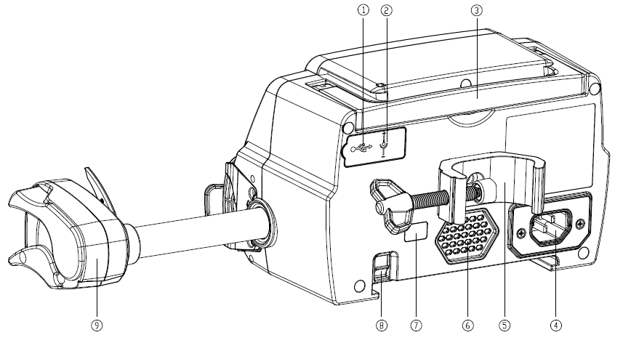

- USB Port
Port only for software upgrade
- DC Input Port
External 12V DC power supply
- Handle
- A/C Adapter Port
External 100-240V 50/60Hz AC power supply
- Pole Clamp
Using for fixing the equipment on the infusion stand
- Loudspeaker
- IrDA
Using for communicating with infusion docking station (Optional)
- Latch for stackable function
- Slider box

Installation

Unpacking and Checking
- Please check the appearance before unpacking, if broken, please contact the transportation company or our after-sale service department quickly.

- Please carefully open the package to avoid damaging the equipment and relevant accessories.

- After unpacking, please check the objects according to the packaging list, if there is insufficient or damaged accessories, please contact our company as soon as possible.

- Please keep relevant accessories, warranty card and User Manual.

- Please keep the packing case and packing materials for future transportation or storage.

Warning: Please put the packing materials out of reach of children. Please obey local laws and regulations or the hospital waste treatment system to handle the packing materials.

Installation
Warning:

- This equipment shall be installed by the designated technicians of our company.

- All devices that connect with this equipment must pass the designated IEC standards (for example: IEC60950 information technology equipment safety and IEC60601-1 medical electric device safety) certification, and all devices must be connected according to the valid version of IEC60601-1-1 system. The technician who takes charge of connecting to additional devices with the equipment interface is responsible for meeting the IEC60601-1-1 standard. Please contact our company if you have any enquiry.

- When connecting this equipment with other electric devices to form the combination with special function, if the combination can’t be confirmed dangerous or not, please contact our company or the electric expert of hospital to ensure that the necessary safety of all devices in the combination won’t be destroyed.

- This equipment must be used and stored in the environment regulated by our company.

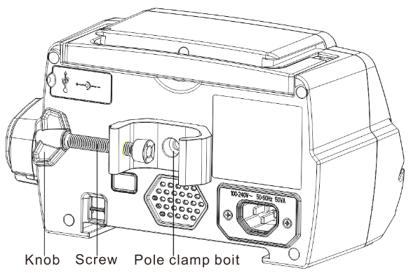
Install the Syringe Driver

(1) Rotate the pole clamp screw(knob) and unscrew to leave the space.

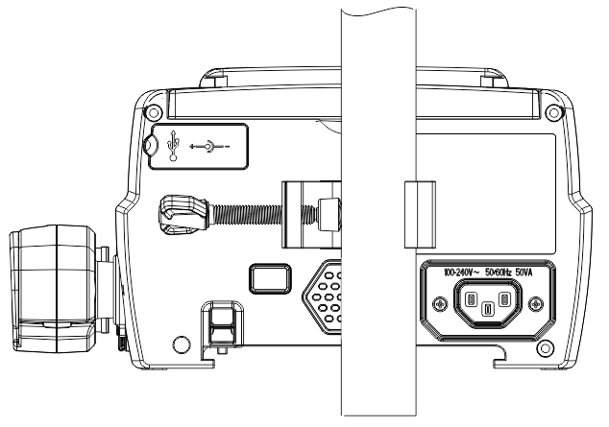
(2) Lock the Pole Clamp on the infusion stand, adjust the position of the syringe pump, tighten the pole clamp to fix the syringe pump on the infusion stand (shown in drawing below). Hold the syringe driver when tightening the fixing clamp; loosen grip slowly after tightening to avoid falling.

(3) The pole clamp supports the vertical pole at default state. To adjust the pole clamp direction, please remove the bolt from the pole clamp screwdriver, take out the pole clamp and adjust the direction, then tighten the bolt.

Use Preparation and Cautions

Use Preparation
The new equipment, or reusing after storing for a period, or reusing after repair, please check it to ensure before use:

- The equipment appearance is clean and under good condition without crack and leakage.

- The moving components are smooth and effective; the button is effective.

- The touch screen can be operated smoothly and effectively.

- The power cord is installed tightly and won’t be easily damaged when pulling.

- Set and check the system time to ensure that the history records will be correctly recorded.

- In case only built-in battery is adopted for supplying power, please charge it to full before using, and ensure that the battery keeps at the effective working conditions.

- Carefully read the Warnings, Cautions and Operation Steps listed in this User Manual.

Operation Cautions
Cautions:
- Avoid direct sunlight, high temperature or high humidity.

- The equipment shall be put at the position less than 0.65m (both up and down) to the heart of the patient.

- The parameters can only be set or changed by the trained and professional personnel.

- Avoid the equipment working with fault so as to avoid medical negligence, which may hurt the health and even life of the patient.

- It may possibly drop the infusion accuracy or abnormal work of the equipment if the working environment temperature exceeds the designated range.

- The viscosity and specific gravity of infusion fluid will influence the infusion accuracy.

Basic Operation

Operation Flow
- Mount the Syringe driver on the IV stand: refer to Chapter 4.2
- Power on: press  two seconds, Power on equipment, refer to Chapter 6.2.2
- Install syringe: refer to Chapter 6.2.3
- Confirm syringe brand and size: select syringe brand or add new brand
- Remove air bubble in the line: refer to Chapter 6.2.5
- Select infusion mode: select infusion modes according to requirement
- Set infusion Parameters: set infusion parameters according to requirement
- Connect infusion line with patient
- Start infusion press , start infusion
- Infusion finish refer to Chapter 6.2.9
- Remove syringe refer to Chapter 6.2.11
- Power off or Standby refer to Chapter 6.2.12

Infusion Operation

Equipment Installation
Mounting the device on the infusion stand according to Chapter 4.2, connect with AC power supply, check the AC indicator lights. Battery will start to charge once AC power connected.

Starting and Self-test
- Press two seconds，power on the equipment
- After power on, the system will automatically check the motor, sensor, battery, memorizer, CPU communication, alarm indicator.
- After passing self-test, pump enters into rate mode interface.

Warning: ● If self-test failed, pump cannot operate properly or damaged, it cannot used for patient infusion, please contact the company.

Install Syringe
- Hold the clutch and pull the slider to the right side.
- Pull the syringe fixture lever, turn 90° right or left.
- Insert the syringe flange into slot, turn syringe fixture lever 90° spring back to tight the syringe.
- Hold the clutch and push leftward, release after it touched the plunger firmly.
- Put extension line of syringe into the extension line hook.
- Click『Setting』→『Commonly used Syringe brand』to choose syringe brand.

Warning:
- Recommend to use syringe brand defaulted in this syringe driver.
- Make sure syringe brand and size in display screen is accordant with the one in use.
- Although self-defined syringe brand function is available, to ensure infusion accuracy and safety, highly suggest to contact our company and ask the professional technician to set and test the user-defined syringe.
Caution：
● Check to ensure no air bubble in syringe.
● Make sure syringe is correctly installed, otherwise accuracy will not assured and may do harm to patient due to no infusion or large dose output due to siphon.

Set Infusion Parameters
refer to Chapter 7.

Remove Air bubble
Under the parameters setting interface, Press 【Bolus】button and hold on, Or touch purge icon on product panel, eliminate the air bubble in the line .
The purge total volume is not calculated in the Total Volume Infused.

Cautions:
● Before purge air, double check to confirm the infusion line is not connected with the patient.
● Purge rate is the max rate of the syringe size, when purge volume ≥5ml, purge will automatically stop.

Start Infusion
Connect syringe extension line with patient, confirm infusion parameters, Press【Start】button , click 『yes』 in the pop-up prompt interface, start infusion.

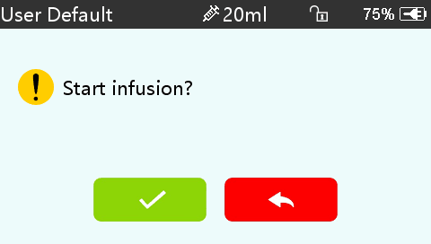

Change the Rate During Infusion
Under running interface, click rate number in touch screen or【Stop】, and enter parameters setting interface, reset target infusion rate.
Note: ● Only the rate mode, time mode and Body weight mode support online rate modification function during infusion without press【Stop】 .

Bolus Application
In operation, Bolus functions have two operation modes: Manual bolus and Automatic bolus.
(1) Manual bolus: press and hold the 【Bolus】button on product panel, pump will work at the max flow rate of current syringe size, or set max bolus rate under setting interface. (syringe flow rate range please. refer to Chapter 2.5), release the button, pump will back to the previous setting infusion rate.
(2) Automatic bolus: Under the running interface, click『Bolus』 on touch screen, set two parameters among bolus infusion volume, rate and time, click『Start』, it will beep at every 1ml infused. After bolus infusion finished, the equipment back to the previous infusion rate.
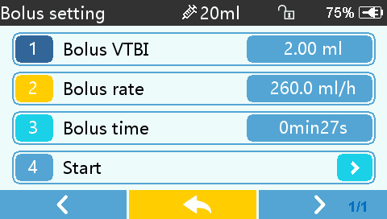

Infusion Completion
When remaining infusion time is near preset volume to be infused completion time, pump will alarm. If ignore it, the system will keep alarming until complete VTBI infusion, for more information please refer to Chapter 8.1.9.
After VTBI completed, it activates VTBI infused alarm, if KVO function is ON, the equipment automatically starts KVO function, click 『OK』 in the alarm interface to stop KVO and eliminate alarm.
The default working time of the KVO system is 30min, after reaching the time, it will activate KVO completion alarm and stop infusion.
Please refer to Chapter 8.1.1 for setting KVO rate.

Stop Infusion
During infusion or after infusion, click, infusion stop. It will return to the parameter setting interface display Total Volume Infused and adjustable parameters.

Remove the syringe
Disconnect the extension line from the patient, then remove the syringe.
Replace syringe, please follow the steps of Chapter 6.2.3.

Power OFF or Standby
Method 1: hold the  【Power】Button till the screen is OFF, the equipment is OFF.
Method 2: press the 【Power】Button to enter into OFF interface.

- Turn off the equipment: click 『Power off』icon, the equipment is turned OFF.
- Standby: click 『Standby』icon to enter into standby time setting interface, set the standby time. Under standby state, the screen brightness will be lowest, after standby, the screen brightness will be recovered.
- Cancel: click『Cancel』, return to the interface before OFF setting.
Note: ● The equipment has standby function only under the non-working state.

Set Infusion Parameters

Introduction to Infusion Parameters Setting
(1) The drug information can be displayed in the infusion running interface only when the drug library is under active state.
Click『Settings』 icon in the main interface to enter sub-menu, find 『Drug Library』menu item, click to enter then set the ON/OFF state of drug library and select drug. Please refer to this User Manual Chapter 9.1 for details.
(2) For both the rate set in infusion parameter and the rate calculated by the system, the range is the system default flow rate of the current working syringe specification.
(3) If didn’t set VTBI (Volume to be infused), which means to complete the fluid/drug in the syringe.

Infusion Parameters Setting Range

Infusion Parameter | Parameter Range
VTBI | 0-9999.99ml
Rate | (0.1-150) ml/h for 5ml syringes  (0.1-300) ml/h for 10ml syringes  (0.1-600) ml/h for 20ml syringes  (0.1-900) ml/h for 30ml syringes  (0.1-1500) ml/h for 50ml syringes
Time | 1min-99hrs59min
Weight (Body weight) | 0.1-300kg
Acti agentia (Drug mass) | 0.01-99999.99
Conc.unit (Concentration unit) | ng、ug、mg、g、U、kU、IU、IE、mmol、mol、kcal
Volume (Fluid amount) | 0.01-9999.99ml
Dose rate | 0.1-9999.99
Dose rate unit | Unit(/kg)/min, Unit(/kg)/h,the Unit is Conc. unit

Infusion Mode Setting
After starting the equipment and self-test, the equipment automatically enters into the rate mode parameters setting interface, to select other mode, click『Menu』icon to enter into the main interface, click『Modes』icon to enter into the mode selection menu interface, and select preset infusion mode.

Rate Mode
Under this mode, it allows to set three parameters: Rate, VTBI (Volume to be infused) and Time, set any two of the three parameters, and the system will automatically calculate the third parameter, if the VTBI is 0, then the equipment works at the set rate till stop with alarm.

Time Mode
Under this mode, it allows to set VTBI (Volume to be infused) and Time, the system will automatically calculate the speed, speed = Volume(ml) /time(min).

Body Weight Mode
Under this mode, set the Weight (body weight), Conc. Unit (concentration unit), Acti agentia(drug mass),Volume(fluid volume), Dose rate, Dose unit, VTBI.
The system will automatically calculate the flow rate from the specified dose rate (ug/kg/min, mg/kg/min, ug/kg/h, mg/kg/h,…etc) according to related formula {dose rate × weight}/{Acti agentia(drug mass)/Volume(fluid volume)}, and automatically calculate the time according to (VTBI) /(flow rate).

Note: ● VTBI must be greater than the Loading dose VTBI otherwise, when setting exceeds the limit, the excess part can’t be set.

System Setting

Settings
Click『Settings』icon in the main interface to enter into parameters setting interface.

Drug Library
Click on the preset drug name, the selected drug will be reflected in infusion mode parameters.
This feature can be turned on and off. Vet Direct Syringe Driver supports 30 drugs, without upper and lower limit.

KVO Rate
Click『KVO rate』, input the numerical value, after confirming, click『OK』.
Please refer to Chapter 2.5 for the adjustable KVO range.

Bolus Rate
Set the default Bolus rate. Please refer to Chapter 2.5 for the range of bolus rate.

Commonly used syringe brand
For the built-in syringe brand of the system, after installing the syringe, click『Commonly used syringe brand』to enter into the syringe brand selecting interface, and click the preset brand option. The system built-in syringe brand: Double Dove.

● The syringe of different brand may possible cause flow rate deviation, when use, please confirm if the displayed information in the interface is accordant with the actual syringe brand in use.

DPS
DPS, Dynamic pressure detection can be carried out after opening, alarm can be triggered when the pressure continues to rise or suddenly falls, this function is optional.

Occlusion Pressure
Click 『Occlusion pressure』to enter into occlusion level setting interface, move the long box to the preset level, after confirming, click 『OK』.
The higher the level, the higher the occlusion level, it is suggested to select suitable occlusion pressure according to actual requirement.

Warning:
- When adopting fluid/drug of high viscosity and the occlusion pressure is set at low level, it is possible that the system will report occlusion alarm even when the line is not obstructed, under this condition, please carefully observe the pressure indication icon in the display screen and infusion line, and rise the occlusion pressure if needed.

- When the occlusion pressure is set to high grade, the big pressure inside the pipeline is likely to pop out the extension line connected to the syringe. Please confirm that the extension line is securely attached to the syringe.

- When the occlusion pressure is set at high level, it may possibly cause the patient uncomfortable, after rising the occlusion pressure, please carefully observe the condition of the patient, and immediately take measure if there’s any abnormality.

- Under the equipment fault state, the max pressure generated by the infusion line is 300kPa. Under single fault state, the max infusion volume is 2ml.

(Table 8.1.2-1 Relation of Occlusion level and Pressure)

Applicable Model: Vet Direct Syringe Driver Occlusion Pressure Level: 3 levels
Level | Pressure Intensity (mmHg) | Level | Pressure Intensity (mmHg) | Level | Pressure Intensity (mmHg)
1 | 300 | 2 | 600 | 3 | 900

Pressure Unit
Click 『Pressure unit』to enter into pressure unit select setting interface, four units are available: mmHg, kPa, bar, PSI, click the preset unit option.

Note: ● Please carefully confirm when changing the current pressure unit.
Unit Mark | Unit Conversion
kPa | 1 kPa=7.5mmHg=0.145psi=0.01bar
PSI | 1psi=51.713mmHg=6.895kpa=0.069bar
Bar | 1bar=787.5mmHg=15.225psi=105kPa

Reminder Alarm
Click『Reminder alarm』to enter into the time for reminder alarm setting interface, click the preset time option to set the reminder alarm time.

Finish Pre-alarm
Time for pre-alarm refers to the time of activating near completion alarm when the fluid/drug infused volume is nearly reaching the preset value.
Click 『Finish pre-alarm』to enter into the time for pre-alarm setting interface, click the preset time option, to set the finish pre-alarm time.

Micro Mode
Click 『Micro mode』 to enter into micro mode setting interface. ON/OFF is optional in this function Optional. Under the ON mode, set the rate limit, then the infusion rate under any infusion mode is not allowed to exceed this limit.

Syringe Size | Max Rate Range
5ml | 100-150ml/h
10ml | 100-300 ml/h
20ml | 100-600 ml/h
30ml | 100-900 ml/h
50ml | 100-1500 ml/h

Reset Total Volume
Click『Reset total volume』, the interface displays the operation confirming prompt box, click『Yes』to confirm reset, otherwise, please click『No』.

General
In the main interface, click『General』to enter into the General equipment setting interface.

Date & Time
Click『Date &Time』to enter into the date and time setting interface. It allows to set the date, time and format in this interface.
When setting date and time, directly input the numerical value in the input method interface. For example, to preset one date “2018-08-31”, input “20180831”; to preset the time “12: 34”, input “1234”.
The time is displayed in 24h format or 12h format, the date is displayed in British type, American type or Chinese type, please set according to the requirement.

Brightness
Click『Brightness』to enter into display brightness setting interface. The brightness has 10 levels.
The equipment has the function of automatic brightness adjustment if external power supply is unavailable. When there is no external power supply, and the power is supplied by battery, if it is not operated within 3min, the system will automatically adjust the brightness to the lowest level, when it is touched or button is clicked by user or when there’s alarm, it will automatically recover the brightness.

Sound
Click『Sound』 to enter into the sound parameters setting interface, the volume has 10 levels. The lowest volume is ≥50dB, and the highest volume is ≤80 dB. Move the long box to the preset value, after confirming, click『OK』

Screen Lock
Click『Screen lock』to enter into automatic lock screen setting interface, select ON or OFF.
Automatic lock screen time can be set at 15s, 30s, 1min, 2min, 5min, 10minor 30min and so on, which means that the equipment will automatically lock the screen if it is not touched or the button is pressed within corresponding time after starting.
Unlock: directly click『Cancel』in the lock screen interface.
Note: ● The equipment will automatically unlock if there’s high Level alarm.

Night Mode
Click『Night mode』 to enter into night mode switch setting interface to set the start and end time of the night mode and the night brightness, at night, the system automatically adjusts the brightness to the User defined value.

Battery capacity display
Turn it on to show the battery life in the upper right corner of the screen, and turn it off to show the percentage of remaining battery life.

Nurse Call
Click『Nurse call』to select function ON and OFF.
Note: ● The nurse call function must be used with special cable.
● The user shall not only depend on the nurse call function as the main alarm notice mode, and shall identify according to the equipment alarm and the patient state.

Nurse call alarm level
By selecting the nurse call alarm level, when the alarm level reaches the selected level, the nurse call alarm is conducted.

Net Work
This equipment supports wireless or wire interconnection, when it is equipped with wireless module and connects with the Internet through WIFI, the equipment screen displays icon.
Click『Net Work』in main interface to set the response.

Note: ● This function shall be set by the professional equipment maintenance technician.
● After activating the interconnection function, the equipment can periodically transmit the equipment data to outside, and the data is only for displaying and doesn’t provide any suggestion on therapy.

The interconnection channel supports WLAN and serial port modes, please select according to the actual requirement.

When WIFI function is in use, turn on the WLAN switch of the equipment, set the name and password of access point, and configure the TCP/IP parameters.

Note: ● The wireless access must be set by the professional technician recognized by our company.
● The transmitted data of this equipment doesn’t provide any suggestion on therapy, and this data shall not be used for calculating the therapeutic schedule.
● When the data is adopted by the third party’s equipment or software, it is only for displaying, and shall not be used for alarming or calculating.

System
Click『System』under the menu interface, enter the system information setting interface

Language
This equipment supports simplified Chinese, English and some other languages.

Factory Default
Click『Factory default』to clear the User defined option, and this function is open to the user.

Version

8.3.3.1 SN (Serial Number)
Check the serial number of the equipment, and user can’t modify the serial number.

8.3.3.2 Software version
Check the software version in this interface.

Maintenance
More detail please. refer to Chapter 11

Other Functions

Patient Information System
Click『Patient』in the main interface to enter into setting interface.

Patient Information
Click『Patient』to enter into the patient information setting interface and set bed number, MRN, name, gender, age, body weight, height.

Prescription
Click『Patient』to enter into the patient information setting interface and enter the end of the sub menu, find menu item 『Prescription』and enter to set the medical advice ID, medical advice information, start time and state.

History entries
Click 『Records』in the main interface to enter sub-menu, click the “History entries” menu item into history records query interface. The equipment supports to save over 5000 history records, and can display the event name, event date and time (permanent preservation). When it is full, the new records will cover the old records with first in first out principle.

Alarm Prompt and Troubleshooting

Introduction to Alarm Level
During infusion preparation and infusion, this equipment will alarm when reaching or exceeding the set alarm threshold value and prompt with sound, light and text. According to the importance of alarm information as well as the emergency and safety, the alarm is divided into three levels: high, middle and low. Please refer to table below for details:

Alarm Level | Sound Signal Interval | Light color /flash frequency
High alarm | 10s | Red indicator flashes /2.0±0.6Hz
Middle alarm | 15s | Yellow indicator flashes / 0.6±0.2Hz
Low alarm | 20s | Yellow indicator lights on

If there’s alarm, the system will display the alarm interface, if the alarm level is high, click 『OK』, stop the alarm, and exit the alarm interface, if the alarm level is middle or low, click 『OK』, the sound signal will stop, and exit the alarm interface.
Click『Mute』to mute, if alarm is not eliminated, the alarm sound will be sent out 2min later.
Warning: ● Some alarm threshold values of this equipment can be set by the user, for example: occlusion pressure, pump idle alarm, VTBI infused pre-alarm, alarm sound volume and so on, the user shall confirm the parameters when set the alarm threshold value, otherwise, it may possibly influence the alarm function or infusion safety.

Multilevel Alarm Rules
When there’re several alarms, the system will alarm according to the following rules:
Table10.2-1

Multilevel Alarm | Rules
Several alarms of different levels generate simultaneously | Display the alarms of highest level with sound, light and text, report middle alarm after eliminating all alarms of highest level
Several alarms of same level generate simultaneously | Alarm circularly by turns, the time interval is 1s
when alarming, the corresponding alarm information will display on the title of the screen. Refer to Appendix C for more information.

Alarm Treatment
Warning: ●When there’s alarm, please check the conditions of the patient, remove the reason of alarm and then continue working.

Please refer to Appendix C for the alarm solution.

Fault Analysis and Solution
When there’s fault, the syringe driver screen will display the fault alarm information, this item is the alarm of high level. Please eliminate the fault alarm according to the prompt. If it can’t be eliminated, please stop the equipment, contact our company to repair and test the equipment, do not put it into operation before the equipment has passed the inspection, otherwise, it may possibly cause unpredictable harm if it works with fault.

If the equipment is on fire/burns for unknown reason, or has other abnormal conditions, the user shall immediately cut off power supply and contact our customer service department.

Maintenance

Cleaning, disinfecting and sterilizing

Warning: ● Please cut off power supply and unplug the DC /AC power cord before cleaning the equipment.

● During cleaning and disinfecting, please keep the equipment horizontal and upwards to protect the equipment and accessories from fluid.

Cleaning
- The daily maintenance is mainly to clean the shell and pump body. It is inevitable that
fluid/drug may flow in the equipment during infusion. Some fluid drug may corrode the pump and cause working fault. After infusion, please timely clean the equipment, wipe it with moist and clean soft fabric, and then naturally dry it.

- When cleaning the equipment interface, please wipe it with dry and soft fabric, confirm the interface is dry before using.

- Please do not soak the equipment in water. Although this equipment has certain waterproof function, when fluid splashes on the equipment, please check if it works normally, perform insulation and electric leakage test if needed.

Disinfecting
- Disinfecting may possibly cause harm of certain degree to the equipment, it is suggested to disinfect the equipment if it is needed.

Please disinfect the equipment with common disinfecting agent such as 50% sodium hypochlorite, cidex 2% glutaraldehyde + activating agent, 70% ethanol, 70% isopropyl alcohol and so on. Please follow the instructions of the disinfecting agent.

- After disinfecting, wet the soft fabric with warm water, squeeze to remove excess water and then wipe the equipment with it.

(3) Do not sterilize the equipment with high pressure steam sterilizer, do not dry the equipment with dryer or similar product.

Warning: ● Please do not adopt Cidex OPA ortho phthalaldehyde, methyl ethyl ketone or similar solvent, otherwise, it may corrode the equipment.

Periodical maintenance
Notes: ● The medical mechanism requires a maintenance plan, otherwise, it may possibly cause the equipment malfunction or fault, and may possibly hurt the physical safety.

● In order to ensure the safe use and prolong the service life of the equipment, it is suggested to periodically maintain and check it once every 6 months. Some items shall be maintained by the user, and some items shall be maintained by the dealer of the equipment.

● Please contact our company if the equipment is found defective.

Check the Appearance

- The appearance of the equipment shall be clean and under good condition without crack and water leakage.
- The buttons are flexible and effective without invalid phenomenon; the sensitivity of the touch screen is normal,
- The slider of the syringe driver is flexible in movement, and the clamp is ok.
- The power cord is under good condition and installed tightly.
- After connecting with external power supply, check whether AC indicator light is on.
- Adopt the accessories designated by our company.
- The environment meets the requirements.

Performance Check
- Self-test and infusion function works.
- Alarm function works well.
- Battery performance.

Maintenance Plan
The following check/maintenance items must be performed by the professional technician recognized by our company. If the following maintenances are necessary, please contact our company. Please clean and disinfect the equipment before testing or maintaining.

Maintenance Items | Cycle
Safety check according to IEC60601-1 | Once every 2 years, please check after replacing the printed circuit board assembly or the equipment is dropped or knocked.
Preventive system maintenance items (pressure calibrate, sensor calibrate, pump) | Once every 2 years, when the occlusion alarm, or infusion accuracy is doubt to be abnormal
Brand of user-defined syringe, infusion accuracy calibration | Using the equipment for the first time, syringe brand using for the first time, reusing the equipment after stopping for a very long period.

Calibration
In the 『System』submenu, click『Brand maintenance』 to enter into brand setting interface, user can add new brand, delete and calibrate the brand.
Warning: ● It is suggested to contact our company or local dealer, to customize or calibrate it by professional technician, otherwise, it may can’t guarantee the infusion accuracy.
Note: ● The built-in brand of the system shall not be deleted.

- Add new brand
If the actual using syringe brand is not listed in the system built-in brand, please add the syringe brand in this interface.
Set syringe brand name and brand information.

(2) Delete brand
Enter into『Delete』interface, click it to delete user-defined syringe brand.

(3) Calibration
Note
- When first time use pump need calibration
- When added new brand need calibration
- When accuracy is not good need calibration.

The following materials shall be prepared before calibration:
A set of new syringe include 2ml、5ml、10ml、20ml、30ml、50/60ml.
Calibrating Steps:
Calibrating Steps:
- Select syringe brand.

- Select syringe size.

- Install syringe, pull the syringe piston beyond size scale line a little, press and hold on [bolus], push the piston to the corresponding size line.

- Press [start], begin calibration

- Calibration completed.

- Exit calibration, the calibrated brand was selected as the current brand, and the infusion accuracy was verified at 5ml/h and 100ml/h flow rates, respectively.

Repair

Normal Repair Process
Please contact our company to repair if there’s any fault, do not disassemble and repair the equipment. After repair, please perform overall test for the equipment. Our company may provide the circuit diagram and components list to the authorized repair technician if needed.

Maintenance for Long Term Store
If the equipment won’t be used for a long period, please take out the battery, and pack it with the equipment in the package, and store it in the shade, cool and dry place without direct sunlight.
The following operations are necessary for using it again:

1. Verify the flow rate accuracy to avoid unconformity between the syringe apparatus parameters in the equipment and the actual parameters after it hasn’t be used for a long period or caused by other reasons, otherwise, it may cause infusion error, influence the therapeutic effects and even cause medical negligence.

2. Perform occlusion alarm test.

3. Test the battery discharging and charging duration to confirm that the battery is also usable.

Equipment Components/Accessories
Warning: ● Only the components and accessories designated by our company shall be adopted, otherwise, it may possibly damage the equipment or drop the equipment performance.

Variety | Name
Equipment Components | Pole clamp
Equipment Components | power cord
Equipment Components | protective cover(optional)

Production Date
Please refer to the label of the product.

Recycling
The normal service life of this equipment is 10 years, and depends on the use frequency and maintenance. The equipment must be rejected after reaching the service life, please contact the manufacturer or the dealer to get more detailed information.

1. The obsolete equipment may be returned to the original dealer or manufacturer.
2. The used lithium-ion polymer battery has the same treatment method, or according to the applicable laws and regulations.
3. Please handle according to the equipment rejecting flow of your medical mechanism.

Battery
This equipment is equipped with charging lithium-ion polymer battery to ensure the normal infusion when the equipment is moved or the external power supply is cut off.

When connecting external power supply, no matter the equipment is started or not, it can charge the battery. When charging, the equipment screen displays the battery charging indication icon . In case only built-in battery is adopted for supplying power, and when the remained battery is less than 20%, please connect the equipment with external power supply to charge the battery.

Warning: ● Only the battery designated by our company shall be adopted.

Check the Battery Performance

The performance of the built-in battery may drop according to the using duration, it is suggested to check the battery once a month.

- Disconnect the equipment from the patient, and stop all infusion.
- Supply AC power to the equipment to charge the battery for 5h at least.
- Supply power for the syringe driver only with battery, infusion at the rate of 5ml/h, test the time till the battery runs down and the equipment is turned off.

- If the infusion time exceeds 10h, the battery keeps at good state.
- If the infusion time exceeds 7h but less than 10h, the battery starts deterioration, but it can be used temporarily.
- If the infusion time is less than 7h, the battery is reaching the service life, please replace the battery.

Replaced the Battery

It is better to replace the battery once every 2 years, it is suggested to replace the battery by the dealer or manufacturer.
The steps of replacing battery are shown as below:
- Cut off the power supply of the equipment, disconnect the power cord. Open the shells and take out the battery.
- Push the new battery into the battery chamber, and insert in the battery fastener.
- After replacing the battery, close the shells, and check the battery.
Warning: ● When replace the battery, please do not touch the 12V DC plug inside of the batter Chamber.

After Sale Service
This product enjoys 1year free warranty after purchase. The warranty period is from the installation date listed on the “Warranty Card”. The “Warranty Card” is the only voucher for calculating the warranty period, in order to maintain your benefit, please carefully fill into and keep the “Warranty Card”, and hand over the copy for the company to the installation technician.

The damages of the equipment caused by the following shall not enjoy free warranty service.

1. Fault caused by incorrect operation, unauthorized refitting or repair.

2. The damages caused by incorrect operation during the transportation process after purchase.

3. The fault and damages caused by fire, salt injury, toxic gas, earthquake, windstorm, flood, abnormal voltage and other natural disasters.

For the damages or faults mentioned above, our company provides repair services but chargeable according to the repair cost.

Manufacturer: Shenzhen MedRena Biotech Co., Ltd.
702, Block A, Youlitong Technology Industrial Park, No. 56 Qingsong Road, Laokeng Community, Longtian Street, Pingshan District, 518122 Shenzhen, P.R. China
TEL: +86 755 28500025

Appendix

Appendix A Start Up Graphs and Trumpet Curves
Appendix A. 1 Start-up Graphs
Brand: Double-Dove Size:50ml
Flow Rate: 1ml/h
Measurement Interval: ∆ t = 0.5min
Measurement duration: T = 2h
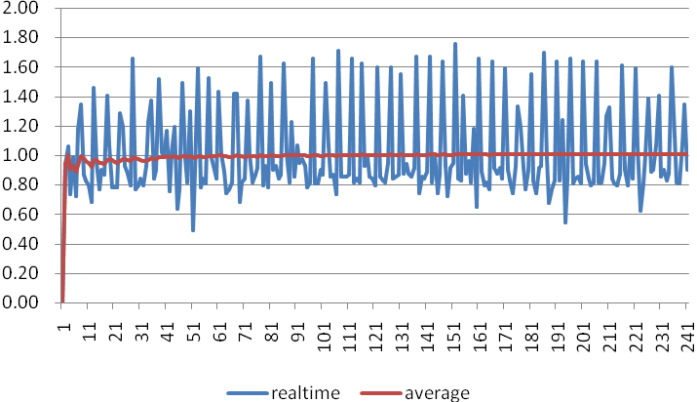
Graph 1 Start-up graph: Flow rate 1 (ml/h) against time (min) plotted from data gathered during the first 2 h of the test period

Brand: Double-Dove Size:50ml
Flow Rate: 5ml/h
Measurement Interval: ∆ t = 0.5min
Measurement duration: T = 2h

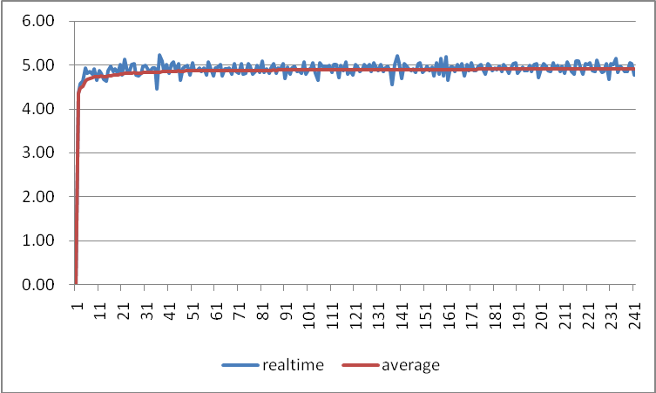

Appendix A.2 Trumpet Curves
Brand: Double-Dove Size:50ml
Flow Rate: 1ml/h
Measurement Interval: ∆ t = 0.5min
Measurement duration: T = 2h
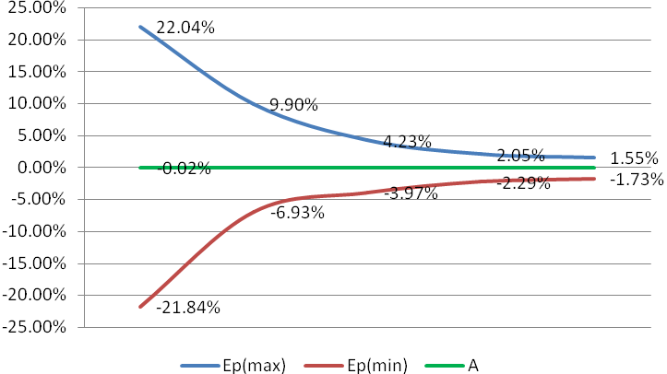
Brand: Double-Dove Size:50ml
Flow Rate:5ml/h
Measurement Interval: ∆ t = 0.5min
Measurement duration: T = 2h

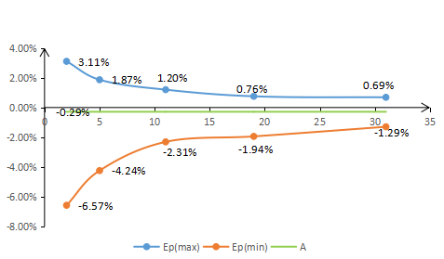

Appendix B Occlusion Response Property
When a occlusion alarm is triggered, the system will automatically processed Anti-bolus, Withdraw according to the current pressure level to reduce the amount of blocking pills.

Vet Direct Syringe Driver occlusion time and bolus relation:
Flow Rate  (ml/h) | Occlusion Pressure  (mmHg) |  | Time to occlusion alarm (min) | Max bolus  (ml)
1 | Low | 300 | 0h49min30sec | 0.037
1 | High | 900 | 2h08min25sec | 0.079
5 | Low | 300 | 0h13min40sec | 0.038
5 | High | 900 | 0h28min23sec | 0.069

Notes: The alarm pressure intensity error is ±20% or ±125mmHg, the higher value shall be taken;

Notes: ● Conditions for testing above data: Syringe Brand: Double-Dove Size:50ml
● The occlusion alarm pressure, alarm delay time and bolus are influenced by the test conditions.
● The above data is the typical value under the test conditions, please see the test data of the product for the actual data, the data may be different if the test conditions are different.

Appendix C Alarm and Solution

Alarm Type | Alarm Level | Reason | Solution
VTBI near end | Low | During infusion, the remaining time of preset value reaches or is less than the set nearing completion time | This alarm can’t be eliminated, and waits till infusion completes
Syringe near empty | Low | The syringe is near empty status which is calculated by checking the liquid medicine remaining in the syringe by current flow rate. | This alarm cannot be eliminated, waiting to syringe empty.
VTBI infused | High | The preset value infusion Completion | Press【Stop】button to stop alarm
Syringe empty | High | The liquid medicine in the syringe is empty. | Press 【Stop】 button to stop the alarm can be eliminated
Pressure near threshold | Middle | Pipeline pressure increases close to the preset blocking level. | Check the connection of the pipeline, press 『OK』button to continue infusion
Pressure drop | Middle | When the pipeline pressure is high, the pressure suddenly decreases. | Check the connection of the infusion pipeline, press 『OK』button to continue infusion
Pressure high | High | 1. Line occlusion during infusion | Click『Mute』to silence, Manually remove the reason of occlusion, Press 【Start】button to continue infusion
Pressure high | High | 2. Fluid/drug in the actual infusion line has high viscosity, but the system occlusion level is set too low | Rise the alarm Level, Press【Start】button to continue infusion
Pressure high | High | 3. The pressure sensor is damaged | Please contact the dealer or manufacturer for repair
Battery nearly empty | Low | 1. When power is supplied only with the built-in battery, under low battery, the alarm duration is >30min | The alarm automatically eliminates after connecting the external power supply.
Battery nearly empty | Low | 2. Battery ageing or the equipment charging circuit is fault. | Please contact the dealer or manufacturer for repair.
Battery empty | High | When power is supplied by the built-in battery only, under low battery, the alarm duration is >30min | Immediately connect with external power supply.
Battery empty | High | 2. Battery ageing or the equipment charging circuit is fault. | Please contact the dealer or manufacturer for repair.
No battery  inserted | Low | Battery is removed | Keep connecting with external power supply, reinstall the battery
No power  supply | Low | Under ON state, AC power supply is adopted, but the AC power cord is dropped during the process | The alarm automatically eliminates after connecting the external power supply.
Check syringe | High | Syringe drop off during infusion | Reinstall the syringe
Pump idle alert | Low | After installing syringe, under non-working or alarm state, it is not operated within the set time of the system | Click any button to stop
Standby time  expired | Middle | During standby, after reaching the standby time | Press 【Stop】button to stop alarm
KVO finished | High | KVO working time reaches 30min, syringe driver stops working | Press 【Stop】button to stop alarm
System Error | High | Internal failure or software exception | Turn off and Restart, if the alarm still exist, please contact the dealer or manufacturer for repair
Note: When alarm rings, click the 『Mute』 icon on the screen to temporarily stop sound alarm for 2min.

Appendix D Electro Magnetic Compatibility declaration
This product needs special precautions regarding EMC and needs to be installed and put into service according to the EMC information provided, and this unit can be affected by portable and mobile RF communications equipment.
Caution:
- This unit has been thoroughly tested and inspected to assure proper performance and operation!
- This machine should not be used adjacent to or stacked with other equipment and that if adjacent or stacked use is necessary, this machine should be observed to verify normal operation in the configuration in which it will be used.
Warning:
The use of ACCESSORIES, transducers and cables other than those specified, with the exception of transducers and cables sold by the MANUFACTURER of the Syringe driver as replacement parts for internal components, may result in increased EMISSIONS or decreased IMMUNITY of the Syringe driver.

Guidance and manufacture’s declaration – electromagnetic emission
The Syringe driver is intended for use in the electromagnetic environment specified below. The customer or the user of the Syringe driver should assure that it is used in such an environment.
Emission s test |  |  | Compliance |  |  | Electromagnetic environment – guidance
RF emissions  CISPR 11 |  |  | Group 1 |  |  | The Syringe driver uses RF energy only for its internal function. Therefore, its RF emissions are very low and are not likely to cause any interference in nearby electronic equipment.
RF emissions  CISPR 11 |  |  | Class A |  |  | The Syringe driver is suitable for use in all establishments, including domestic establishments and those directly connected to the public low-voltage power supply network that supplies buildings used for domestic purposes.
Harmonic emissions  IEC 61000-3-2 |  |  | Not applicable
Voltage fluctuations/ flicker emissions  IEC 61000-3-3 |  |  | Not applicable
Guidance and manufacture’s declaration – electromagnetic immunity
The Syringe driver is intended for use in the electromagnetic environment specified below. The customer or the user of the Syringe driver should assure that it is used in such an environment.
Immunity test | IEC 60601 test level |  |  | Compliance level |  |  | Electromagnetic environment - guidance
Electrostatic discharge (ESD)  IEC 61000-4-2 | ±6 kV contact  ±8 kV air |  |  | ±8 kV contact  ±15 kV air |  |  | Floors should be wood, concrete or ceramic tile. If floors are covered with synthetic material, the relative humidity should be at least 30%.
Electrical fast transient/burst  IEC 61000-4-4 | ±2 kV for power supply lines  +1 KV for input/output lines |  |  | ±2kV for power supply lines |  |  | Mains power quality should be that of a typical commercial or hospital environment.
Surge  IEC 61000-4-5 | ± 1 kV line(s) to line(s)  +2 KV line(s)to earth |  |  | ± 1 kV line(s) to line(s)  +2 KV line(s)to earth |  |  | Mains power quality should be that of a typical commercial or hospital environment.
Voltage dips, short interruptions and voltage variations on power supply input lines  IEC 61000-4-11 | <5% UT  (>95% dip in UT)  for 0.5 cycle  40% UT  (60% dip in UT)  for 5 cycles  70% UT  (30% dip in UT)  for 25 cycles  <5% UT  (>95% dip in UT)  for 5 sec |  |  | <5% UT  (>95% dip in UT)  for 0.5 cycle  40% UT  (60% dip in UT)  for 5 cycles  70% UT  (30% dip in UT)  for 25 cycles  <5% UT  (>95% dip in UT)  for 5 sec |  |  | Mains power quality should be that of a typical commercial or hospital environment. If the user of the Syringe driver requires continued operation during power mains interruptions, it is recommended that the Syringe driver be powered from an uninterruptible power supply or a battery.
Power frequency (50Hz/60Hz) magnetic field IEC 61000-4-8 | 3 A/m |  |  | 400A/m |  |  | Power frequency magnetic fields should be at levels characteristic of a typical location in a typical commercial or hospital environment.
NOTE UT is the a.c. mains voltage prior to application of the test level.
Guidance and manufacture’s declaration – electromagnetic immunity
The Syringe driver is intended for use in the electromagnetic environment specified below. The customer or the user of Syringe driver should assure that it is used in such an environment.
Immunity test |  | IEC 60601 test level |  |  | Compliance level |  | Electromagnetic environment - guidance
Conducted RF  IEC 61000-4-6 |  | 3 Vrms  150 kHz to 80 MHz |  |  | 10 Vrms |  | Portable and mobile RF communications equipment should be used no closer to any part of the Syringe driver, including cables, than the recommended separation distance calculated from the equation applicable to the frequency of the transmitter.  Recommended separation distance  d = 1.167  d = 1.167 80 MHz to 800 MHz  d = 2.333 800 MHz to 2.5 GHz  Where P is the maximum output power rating of the transmitter in watts (W) according to the transmitter manufacturer and d is the recommended separation distance in meters (m).  Field strengths from fixed RF transmitters, as determined by an electromagnetic site survey, it should be less than the compliance level in each frequency range. b  Interference may occur in the vicinity of equipment marked with the following symbol:  
Radiated RF  IEC 61000-4-3 |  | 3 V/m  80 MHz to 2.5 GHz |  |  | 10 V/m
NOTE 1 At 80 MHz and 800 MHz, the higher frequency range applies.
NOTE 2 These guidelines may not apply in all situations. Electromagnetic propagation is affected by absorption and reflection from structures, objects and people.
a Field strengths from fixed transmitters, such as base stations for radio (cellular/cordless) telephones and land mobile radios, amateur radio, AM and FM radio broadcast and TV broadcast cannot be predicted theoretically with accuracy. To assess the electromagnetic environment due to fixed RF transmitters, an electromagnetic site survey should be considered. If the measured field strength in the location in which the Syringe driver is used exceeds the applicable RE compliance level above the Syringe driver should be observed to verify normal operation. If abnormal performance is observed, additional measures may be necessary, such as reorienting or relocating the Syringe driver.
b Over the frequency range 150 kHz to 80 MHz, field strengths should be less than 3 V/m.

Recommended separation distances between
portable and mobile RF communications equipment and the Syringe driver.
The Syringe driver is intended for use in an electromagnetic environment in which radiated RF disturbances are controlled. The customer or the user of the Syringe driver can help prevent electromagnetic interference by maintaining a minimum distance between portable and mobile RF communications equipment (transmitters) and the Syringe driver as recommended below, according to the maximum output power of the communications equipment.
Rated maximum output power of transmitter  (W) | Separation distance according to frequency of transmitter (m)
Rated maximum output power of transmitter  (W) | 150 KHz to 80 MHz  d = 1.167 | 80 MHz to 800 MHz  d = 1.167 | 800 MHz to 2.5 GHz  d = 2.333
0.01 | 0.117 | 0.117 | 0.233
0.1 | 0.369 | 0.369 | 0.738
1 | 1.167 | 1.167 | 2.333
10 | 3.689 | 3.689 | 7.379
100 | 11.667 | 11.667 | 23.333
For transmitters rated at a maximum output power not listed above, the recommended separation distance d in meters (m) can be estimated using the equation applicable to the frequency of the transmitter, where P is the maximum output power rating of the transmitter in watts (W) according to the transmitter manufacturer.
NOTE 1 At 80 MHz and 800 MHz, the separation distance for the higher frequency range applies.
NOTE 2 These guidelines may not apply in all situations. Electromagnetic propagation is affected by absorption and reflection from structures, objects and people.

Appendix E Factory Default Data Set

Parameters | Default Setting | Parameters | Default Setting
KVO rate | 1ml/h | Sound | 40%
Occlusion pressure | 600mmHg | Screen lock | ON
Finish pre-alarm | 2min | Brightness | 90%
Reminder alarm | 2min | Night mode | OFF
Pressure unit | mmHg | Nurse call | OFF
Micro mode | OFF | Drug Library | OFF
Commonly used syringe brand | Double Dove | Relay mode | OFF


34-000008-00

